Using Tactile Rhythm to Convey Interpersonal Distances to Individuals who are Blind

Abstract

Copyright is held by the author/owner(s).

CHI 2009, April 4–9, 2009, Boston, Massachusetts, USA.
ACM 978-1-60558-247-4/09/04.
Troy McDaniel, Sreekar Krishna, Dirk Colbry and Sethuraman Panchanathan
Center for Cognitive Ubiquitous Computing
Department of Computer Science and Engineering
School of Computing and Informatics
Arizona State University
Tempe, AZ, USA 85281

troy.mcdaniel@asu.edu
sreekar.krishna@asu.edu
dirk@colbry.com
panch@asu.edu

http://cubic.asu.edu

This paper presents a scheme for using tactile rhythms to convey interpersonal distance to individuals who are blind or visually impaired, with the goal of providing access to non-verbal cues during social interactions. A preliminary experiment revealed that subjects could identify the proposed tactile rhythms and found them intuitive for the given application. Future work aims to improve recognition results and increase the number of interpersonal distances conveyed by incorporating temporal change information into the proposed methodology.

Keywords
Tactons, tactile icons, haptic icons, haptic belt, vibrotactile belt, assistive technology

ACM Classification Keywords
H5.2. User Interfaces: Haptic I/O.

Introduction
Good social skills develop early in life and help individuals become healthy and successful [10]. Typically, social interactions occur through verbal and non-verbal interaction cues. While verbal cues are mostly auditory in nature, non-verbal cues depend heavily on visual aspects of the communicators and their environment [7]. Individuals who are blind are at a disadvantage when interacting with sighted peers as they do not have access to all or most of the non-verbal cues. As a result, inadequate social skills may develop causing awkward or embarrassing situations that lead to social anxieties and possibly social isolation. The research described here tries to enhance social interactions by developing assistive technologies to detect and convey non-verbal cues.
We conducted an online survey of professionals and students who are blind or visually impaired to learn which non-verbal cues are most important for social accessibility [8]. The results of this study showed the following cues to be important during social interactions: (1) the number of people standing in front of you and where each person is standing; (2) when a person is directing his or her attention at you; (3) the identities of the people standing in front of you; and (4) the appearance of the people standing in front of you.
As a first step (see [8]), we focused on the two challenges that were ranked by survey participants as most important: identifying the location and identity of communicators. We built a Social Interaction Assistant that uses a wearable video camera to extract social cues via computer vision techniques; output about social cues is delivered via headphones and/or a vibrotactile belt. Since audio output can obstruct hearing, whenever possible we opted to provide social cues via the sense of touch.
For example, our system conveys the location of someone in front of the user using two pieces of information: the individual’s direction relative to the user and the interpersonal distance. Computer vision algorithms are used to extract this information from data about the location and size of the face detected by the wearable camera. The relative direction of the individual is communicated by the location of a vibration on the vibrotactile belt, while the duration of the vibration communicates the interpersonal distance. Five different vibration durations (200ms, 400ms, 600ms, 800ms, and 1000ms) were chosen to indicate different interpersonal distances. The perception of these vibration lengths was experimentally evaluated and we found that although 200ms and 400ms were easy to discriminate, vibration lengths of 600ms, 800ms and 1000ms were often confused.
In this paper, we present the initial findings of our effort towards improving the communication of location and interpersonal distance through the use of tactile rhythms. Tactile rhythms, like audio rhythms, refer to patterns created by selectively turning on and off vibratory motors. Distances are invariably communicated using audio rhythms by linearly/exponentially varying the off duration with the distance. This is an intuitive choice for conveying distance information, which motivated our decision to use tactile rhythm with a similar design. Moreover, rhythm is preferred over many other dimensions of vibratory signals, such as frequency or amplitude, for use in encoding meanings into vibrations as tactile rhythms are easy to discriminate between [2].

Background and Related Work
In [9], Ram and Sharf introduced The People Sensor: an electronic travel aid, for individuals who are blind, designed to help detect and localize people and objects in front of the user. The distance between the user and an obstacle is found using ultrasonic sensors and communicated through the rate of short vibratory pulses, where the rate is inversely proportional to distance. However, the researchers did no user testing to determine the usefulness of their technology. Tactile rhythms delivered using a vibrotactile belt were used in [4] to convey distance information during waypoint navigation. Time between vibratory pulses was varied using one of two schemes: monotonic (rate is inversely proportional to distance) or three-phase-model (three distinct rhythms mapped to three distances).
Distinct tactile rhythms are promising for use with multidimensional tactons [1, 2], which are vibratory signals used to communicate abstract messages [2] by changing the dimensions of the signal including frequency, amplitude, location, rhythm, etc. Based on pilot test results, we chose to pursue distinct rhythms over monotonic rhythms as users find it difficult to identify interpersonal distances using monotonic rhythms as the vibratory signal varies smoothly with changes in distance.
In behavioral psychology, influences of interpersonal distances on social interactions between people have been studied for over four decades. The term proxemics, coined by Edward T. Hall, describes influence of interpersonal distances in animal and man [6]. The following list describes the American proxemic distances; note that such distances vary with culture and environment.
- Intimate Distance (Close Phase): 0-6 inches
- Intimate Distance (Far Phase): 6-18 inches
- Personal Distance (Close Phase): 1.5-2.5 feet
- Personal Distance (Far Phase): 2.5-4 feet
- Social Distance (Close Phase): 4-7 feet
- Social Distance (Far Phase): 7-12 feet
- Public Distance (Close Phase): 12-25 feet
- Public Distance (Far Phase): 25 feet or more
In this work, only interpersonal distances within intimate, personal and social spaces are considered as most one-to-one social interactions take place in these spaces.

Tactile Rhythm Design
The tactile rhythms used in our experiments were motivated by results reported in [5], where just noticeable differences of vibrotactile duration were assessed. Subjects perceived pulses of duration below 100ms as a poke or nudge. Between 100ms to 2000ms, the just noticeable difference is an increasing curvilinear function of duration; although between 100ms to 500ms, the function is approximately linear. Based on these results, Geldard [5] recommended three durations, specifically 100ms, 300ms and 500ms, for accurate identification by subjects.
We conducted pilot studies to determine rhythm patterns that are convenient for users to identify vibratory rhythms. Through use of a vibrotactile belt, we evaluated use of five rhythms, each 10 seconds in length: 50ms vibrotactile pulses separated by pauses of length 50ms, 100ms, 300ms, 500ms and 1000ms. Subjects found rhythms with pauses of 100ms, 300ms and 500ms difficult to discriminate between. Based on these findings, we selected the four rhythms depicted in figure 1; this design includes more separation of pauses within 100ms to 500ms, and a small increase of 1000ms to 1200ms (much longer durations may be too time consuming for communication [5]). In the Social Interaction Assistant, these four tactile rhythms are mapped to interpersonal distances corresponding to intimate, personal (close phase), personal (far phase) and social (close phase) space respectively.
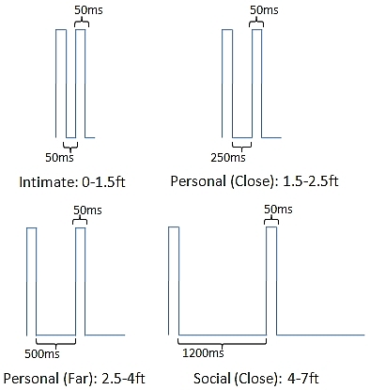
figure 1. The on/off timing values of the four tactile rhythm designs, and corresponding distances, used in the experiment.

Experiment

Aim: The aim of this experiment is to evaluate participants’ performance identifying the tactile rhythms of figure 1 as they relate to interpersonal distances. Moreover, to ensure that the proposed tactile rhythms do not hamper subjects’ ability to localize vibrations, as evaluated in previous work [8] to convey directions, we evaluate how well subjects can identify both cues as conveyed through tactons.

Hypotheses: (1) Subjects will achieve at least 90% accuracy at identification of tactile rhythms; (2) Subjects will achieve at least 90% accuracy at identification of vibration locations; (3) Subjects will achieve at least 80% accuracy at identification of complete tactons;(4) Subjects’ ability to localize vibrations will depend on the location of the vibration motor (tactor) around the waist; (5) Subjects’ ability to identify tactile rhythms will depend on the type of rhythm; and (6) Subjects’ ability to localize vibrations will not depend on rhythm type, and vice versa.

Subjects: 11 males and 4 females of ages 22 to 60 (avg. 32) participated; one subject is visually impaired.

Apparatus: An elastic vibrotactile belt [8] was used for this experiment. The design of the belt was based on the experiments of Cholewiak, et al. [3]. The belt consists of 7 tactors equidistantly placed in a semi-circle with the first, fourth and seventh tactor at the user’s left side, navel, and right side, respectively. Each tactor consists of a pancake motor of diameter 10mm and length of 3.4mm, and operates at 170Hz.

Procedure: Subjects wore the belt underneath their clothing and sat during the entire experiment. Subjects had access to visual guides—a semi-circle with tactors #1-7 drawn and interpersonal distances labeled as rhythms #1-4—to recall tactor and rhythm numbers, respectively. First, subjects were familiarized with vibration location as it pertains to direction. Each tactor was vibrated for 3 seconds, and the tactor number was called out by the experimenter. Next, subjects were familiarized with tactile rhythms. Each rhythm was presented for 7 seconds through the fourth tactor at the navel, and the rhythm number was called out by the experimenter. Next, subjects began the training phase where they were asked to identify the direction (through the location of the activated tactor) and distance (through the type of rhythm) indicated by each tacton. All 28 tactons (4 tactile rhythms at 7 different locations/tactors) were randomly presented for 10 seconds each. Subjects were encouraged to respond before the 10 seconds ended. Subjects had to achieve a recognition accuracy of 80% or more on each tacton dimension to proceed immediately to the testing phase; otherwise, the training phase was repeated (only 6 subjects had to repeat training, and all passed on the second try). The experimenter corrected wrong guesses and confirmed correct guesses. The testing phase was similar to the training phase, except no feedback was provided by the experimenter concerning right or wrong guesses, and each of the 28 tactons was randomly presented 3 times for a total of 84 trials.

Results: The overall recognition accuracy follows: location (mean: 95%, SD: 4%), rhythm (mean: 91.7%, SD: 5.7%) and both (mean: 87%, SD: 8.5%). These results support hypotheses (1)-(3), and show that, overall, subjects had little difficulty in recognizing rhythms and locations as they pertain to distance and direction, respectively. Feedback from participants after the experiment further supported this. From herein, reported ANOVA results are from a two-way ANOVA on complete tacton recognition accuracy through location and rhythm. The overall recognition accuracy of each tactor location is shown in figure 2. Subjects felt that the vibrations of tactor #1 (left side), #4 (navel) and #7 (right side), were easier to localize compared to tactor #2, #3, #5 and #6. This result is easy to explain as spatial acuity is better at anatomical reference points [3]. Although figure 2 does show a very small difference between recognition accuracies, which supports what subjects reported, there was no significant difference between recognition accuracy of tactor locations [F(6,1232)=1.96, p=0.068], hence hypothesis (4) cannot be accepted. The overall recognition accuracy of rhythms is shown in figure 3. Subjects felt that rhythm #2 (personal-close) and #3 (personal-far) were more difficult to identify than rhythm #1 (intimate) or #4 (social-close), which is supported by figure 3. A significant difference between recognition accuracy of rhythms [F(3,1232) =5.70, p=0.001] supported hypothesis (5). No interaction was found between location and rhythm for recognition accuracy of complete tactons [F(18,1232)=0.91, p=0.569], supporting hypothesis (6).
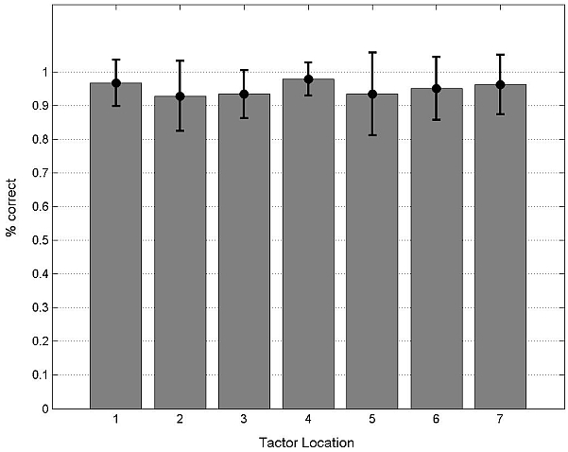
figure 2. Overall direction recognition accuracy of each tactor location with standard deviations.
After the experiment, subjects filled out 10-level Likert scales—1 (lowest) to 10 (highest). Subjects rated their ability to localize vibrations (mean: 8.4), identify rhythms (mean: 7.4), intuitiveness of location to convey direction (mean: 9.7) and intuitiveness of rhythm to convey distance (mean: 8.9). Overall, subjects felt that they could accurately identify the proposed tactons, although identifying direction was easier than distance, and both schemes were intuitive.
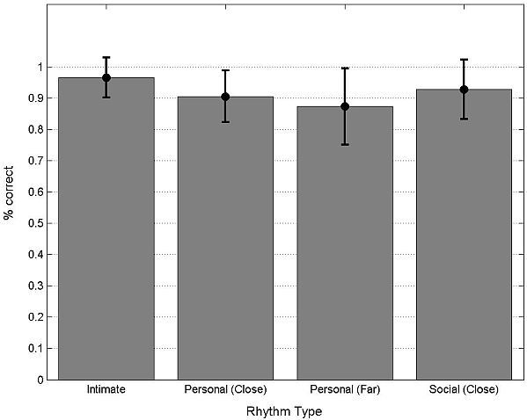
figure 3. Overall distance recognition accuracy of each rhythm type with standard deviations.

Future Work
Although the preliminary results presented here are promising, there are several areas for improvement that will be our focus for future work. All subjects reported that rhythms #2 and #3 felt similar, which sometimes caused confusion. We believe that what is missing in the current evaluation is temporal information. During actual use of the system, as interpersonal distance between communicators changes, rhythms will vary, which should aid absolute identification of rhythm. How temporal information affects absolute identification of tactile rhythm will be investigated as part of future work. Ultimately, we wish to design a scheme that can convey all 8 interpersonal distances through touch, which we believe might be possible through the use of temporal information.

Acknowledgements
This work is supported by NSF grant ITR 0326544.

References
- P. Barralon et al. Development and evaluation of multidimensional tactons for a wearable tactile display. MobileHCI, 2007, 186-189.
- L. Brown et al. A first investigation into the effectiveness of tactons. World Haptics, 2005, 167-176.
- R.W. Cholewiak et al. Vibrotactile localization on the abdomen: effects of place and space. Perception and Psychophysics, vol. 66, 2004, 970-987.
- J.B.F.V. Erp et al. Waypoint navigation with a vibrotactile waist belt. ACM Trans. Appl. Percept., vol. 2, 2005, 106-117.
- F.A. Geldard. Adventures in tactile literacy. American Psychologist, vol. 12(3), 1957, 115-124.
- E.T. Hall. The hidden dimension, Garden City, New York: Double Day & Company, Inc., 1966.
- M.L. Knapp et al. Nonverbal Communication in Human Interaction, Wadsworth/Thomson Learning, ‘05.
- T. McDaniel et al. Using a haptic belt to convey non-verbal communication cues during social interactions to individuals who are blind. HAVE, 2008, 13-18.
- S. Ram and J. Sharf. The people sensor: a mobility aid for the visually impaired. ISWC, 1998, 166-167.
- S. Sacks et al. The Development of Social Skills by Blind and Visually Impaired Students, New York: AFB Press, 1992.

